 | Type A  Storybook / Cartoonish | Type B  Stylized/Abstract /  Graphic Decor | Type C  Low Realistic Detail | Type D  High Realistic Detail
Art examples | 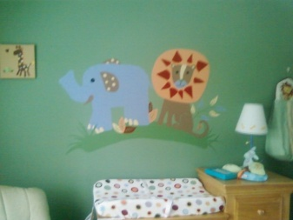 | 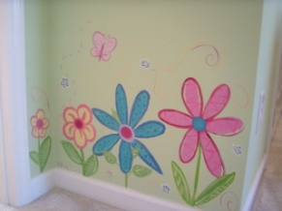 | 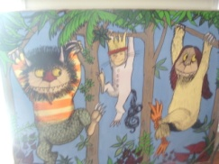 | 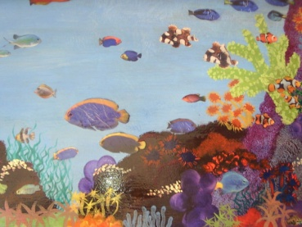
 | Style is simple with little detail usually depicting a character from a story or matching bedding. | Bold accents of graphic art used to accentuate a door, lobby, kitchen, or furniture. | Detailed depictions of characters, animals, or scenery. | Paintings either involving multiple perspectives or high realistic detail.
UNDER  15  SQ. FT. | $20/SQ. FT. | $30/ SQ. FT. | $60/ SQ. FT. | $70/ SQ. FT.
15 - 25  SQ. FT. | $15/ SQ. FT. | $25/ SQ. FT. | $45/ SQ. FT. | $60/ SQ. FT.
25 - 50  SQ. FT. | $10/ SQ. FT. | $20/ SQ. FT. | $40/ SQ. FT. | $55/ SQ. FT.
50 - 120  SQ. FT. | $8/ SQ. FT. | $18/ SQ. FT. | $30/ SQ. FT. | $50/ SQ. FT.

